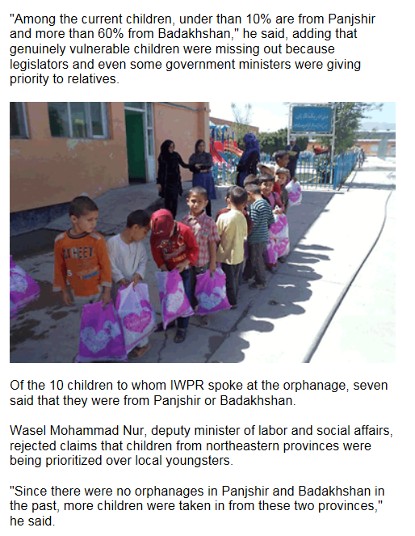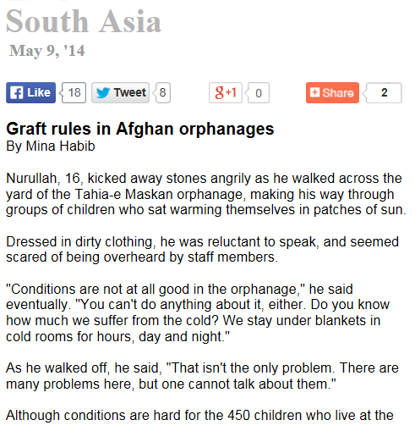

This reminds me of the orphanage that Laila brought Aziza to, with poor conditions

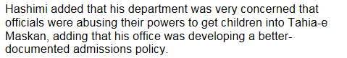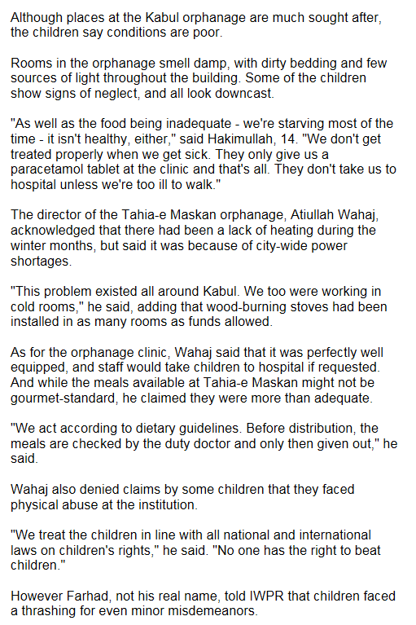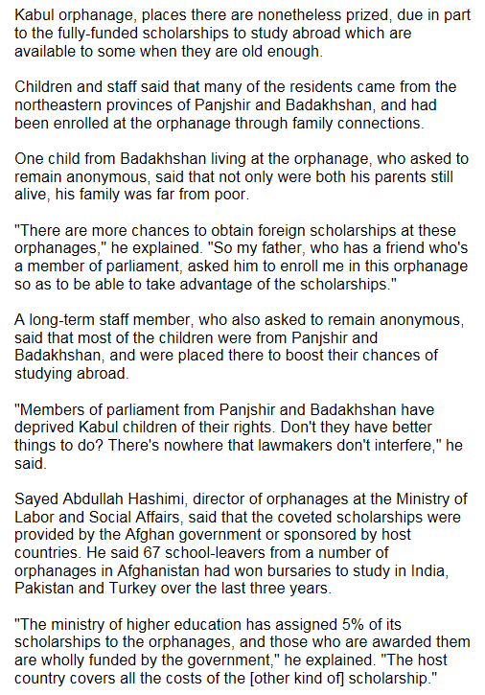

This is how Laila described some parts of the orphanage

This is probably the only difference though. Zaman did not and would not lay a finger on these children.

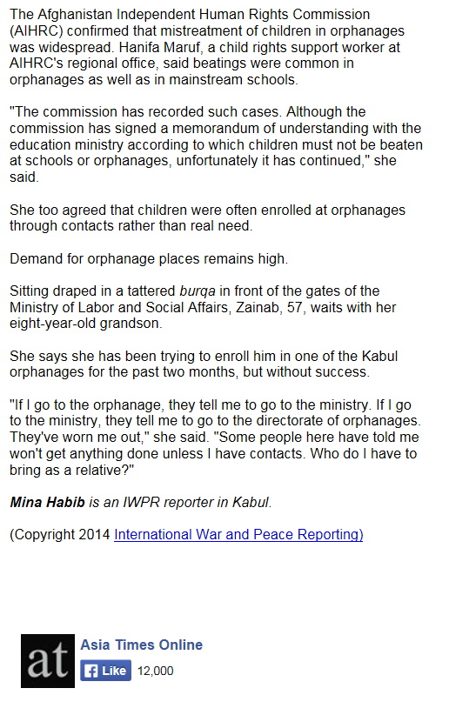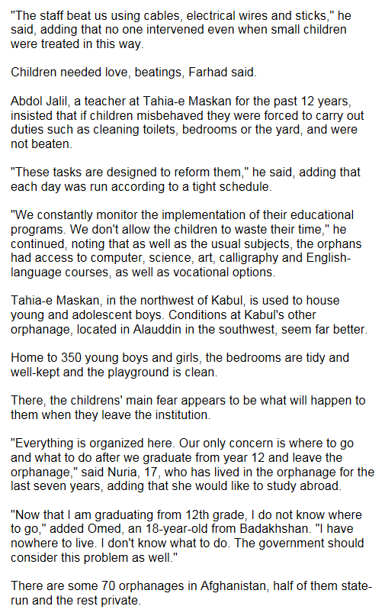

Reminds me of Khala Rhangmaal when Laila saw her visiting her three children at the orphanage.

All of the children’s bedrooms that were being used were tidy as well.