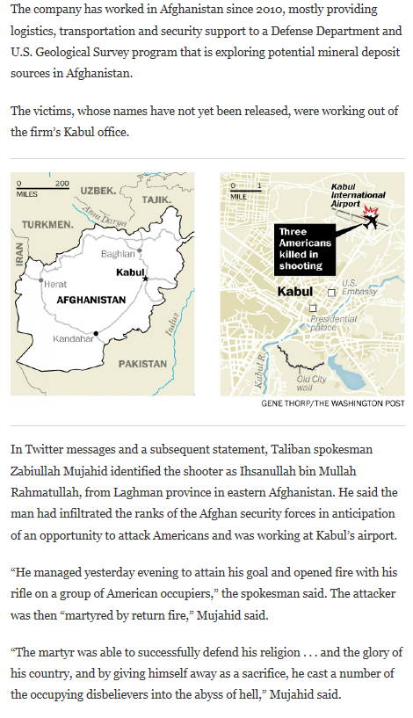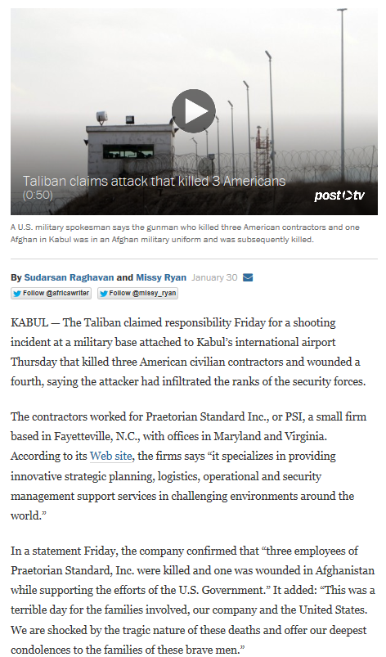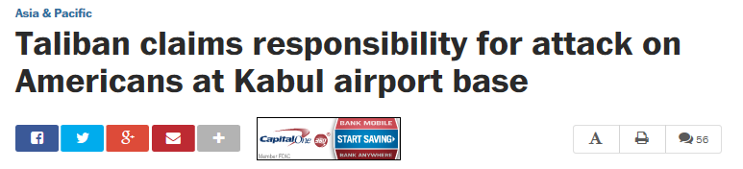

Very similar to Mujahedeen, one of the Warlords before the Taliban

The Taliban again are in Kabul, killing people, just as they were in the early 2000’s after the end of the Soviet reign.

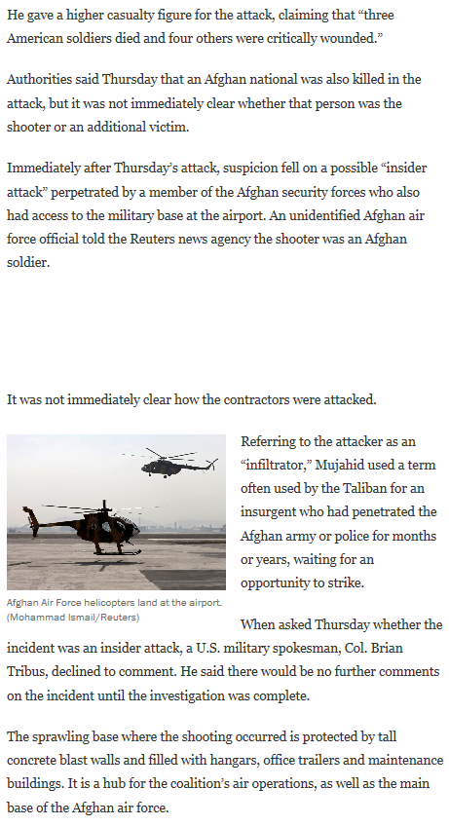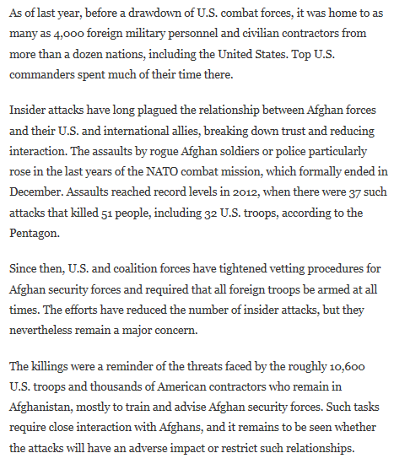

During their reign in Kabul in ATSS, the Taliban killed many innocent people just as these three contractors; most of them for no reason at all.

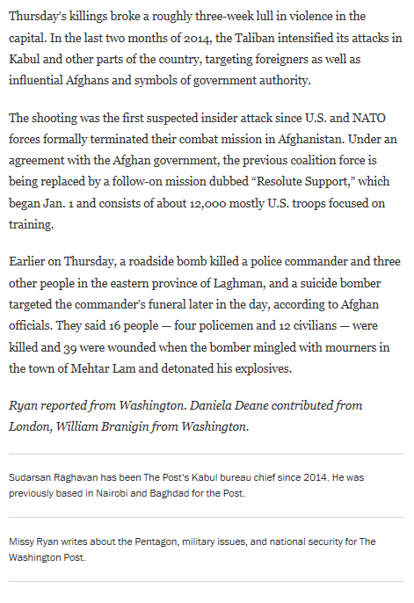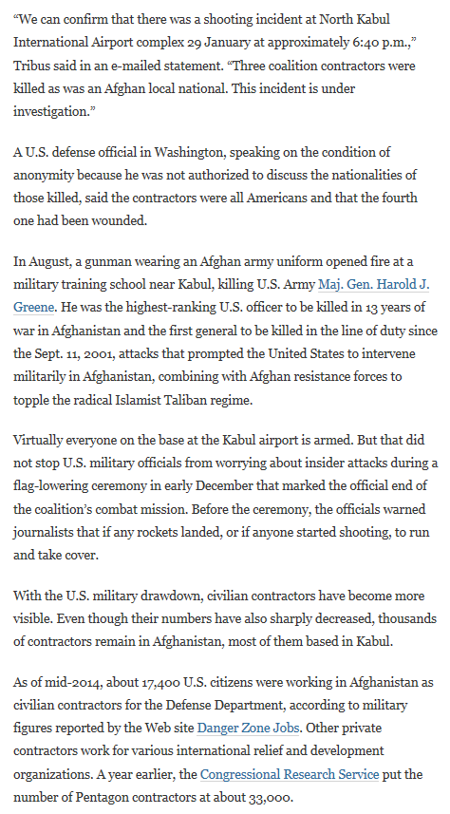V

The Taliban did this in Kabul many years ago as well.